**Homepage Copy**

**CLIENT:** WorldSurf.com

**UI Designer:** TBA

**A World of Waves at your Fingertips**

See the outer reefs of Bali. Save Morocco’s “Money Wave”. Surf Tavarua from your own virtual seat at “Restaurants”. Explore a world of surf… from anywhere in the world.

**Featured Destination: Supertubos, Peniche Portugal**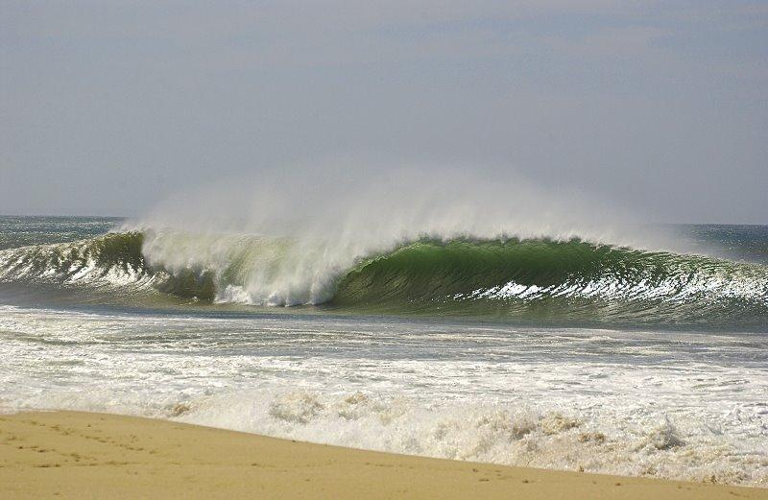

**Description**

Make no mistake: Supertubos is one of the best waves in Europe. There's one main peak with a super-fast (though makeable) left, and a somewhat shorter right, and one other peak down the beach that's not quite as perfect but still way better than your average day at Huntington Pier.

**Members**

Worldsurf.com provides its members with access to premium “members only” features like:

* “WorldSurf Cams”
  + *See what the conditions are like 24 hours a day 7 days a week with our destination cams. Exclusive to worldsurf.com members*
* “Tips & Tricks”
  + *Get advice from other surfers that have “been-there-done-that” to make your next surf trip the best it can be.*
* “Surf Saver”
  + Save and revisit your favorite surf destinations to make the decision of where to go next, easier.

Worlsurf.com is a fictitious site intended for educational purposes only